Progress Report

Quick Summary
This week, I revised and updated both the front and side of the smart glasses frame, confirmed the functionality of the camera and microphone on the ESP32-S3, and integrated them into our pipeline for audio and image data. The system now reliably captures and processes image inputs. Next up is to work on PCB Design For camera and frames, minor mechanical fixes, and validation toward a fully integrated prototype in around 3 weeks
View | Initial Design | Updated Design
Isometric | 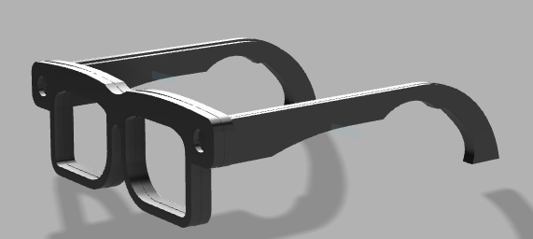 | 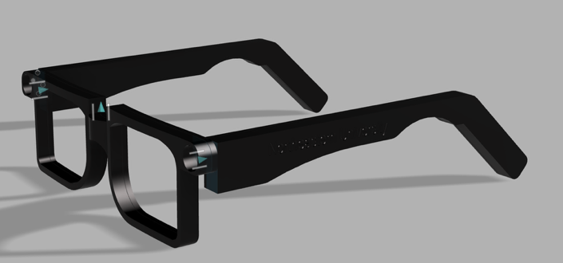
Front View | 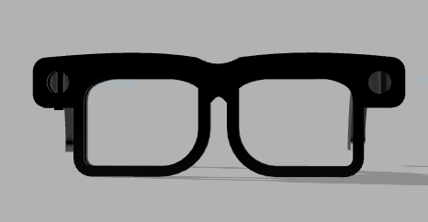 | 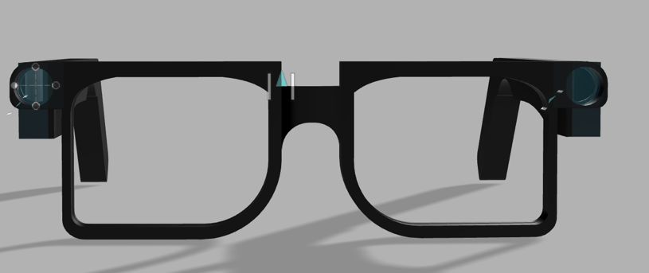
Side View | 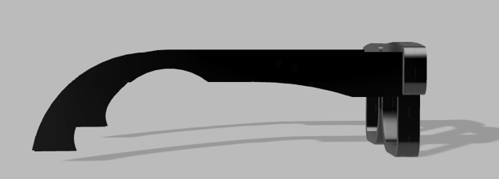 | 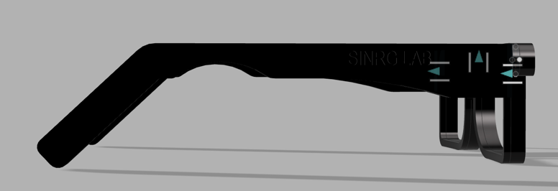

1. Hardware & Mechanical Updates

Frame and Arms
- Updated the ends of the arms to be straight, allowing proper accommodation of the battery.
- Added branding to the arms:
  - Left side: “Northeastern”
  - Right side: “Sinrg Lab”
- The front frames have been significantly thinned, resulting in a more discrete and wearable design.

Camera Housing
- Identified a mismatch in the camera hole dimensions.
  - Initial measurements appear to have been based on a different ESP32 Sense camera.
  - Adjustments are required to properly fit the OV3660 camera.

2. S3 Updates
- Camera is now fully operational
- Microphone is confirmed working
- Overall, the ESP32-S3 hardware is functioning as expected for both audio and image capture.
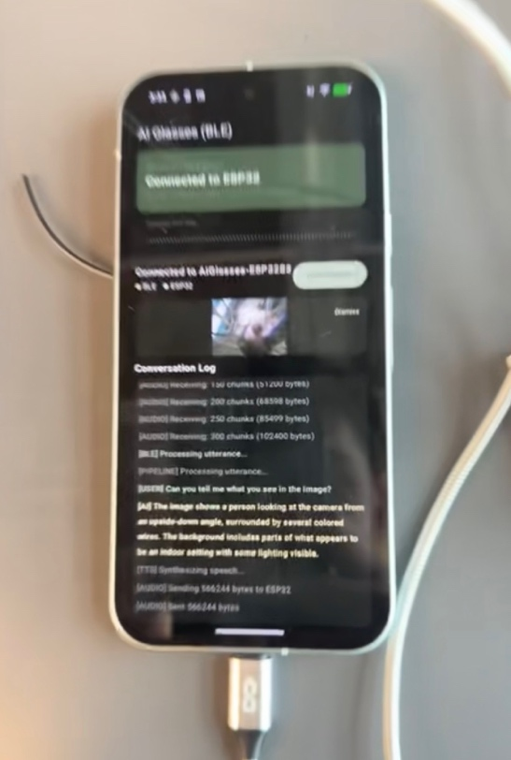
Transcription:
[USER] Can you tell me what you see in the image?
[AI] The image shows a person looking at the camera from an upside-down angle, surrounded by several colored wires. The background includes parts of what appears to be an indoor setting with some lighting visible.

3. Software & BLE Pipeline Overview
The camera and microphone data pipeline is now functional and integrated through the BLE service:

BLE Voice Service Architecture
- BleVoiceService.kt manages:
  - Bluetooth Low Energy (BLE) communication
  - Data ingestion into the AI processing pipeline
- The service listens on three BLE notification channels simultaneously:
  - Audio TX – Streams audio chunks and accumulates them in a buffer
  - Image TX – Streams image chunks and assembles them into a full JPEG
  - Control Channel – Sends markers that manage session state

Control Markers
- I → Start of image capture (resets image buffer)
- J → End of image capture (JPEG is complete and UI preview is displayed)
- E → End of audio capture (triggers processReceivedAudio())

Processing Logic
At the E marker, the service determines the processing path:
- Audio + image captured → pipeline.processWithVision()
- Audio only → pipeline.process()

Next Steps
- PCB Design
  - Akash will design the PCB within the current frame constraints.
  - The frame will be adjusted where necessary to accommodate PCB limitations.
- Mechanical Adjustments
  - Correct the front frame for the camera module.
  - Adjust camera placement for compatibility with smart hinges.
  - Order smart hinges (OBE Smart Glasses Hinges).
- Validation & Testing
  - PCB validation and ordering.
  - Performance testing and camera firmware optimization.

5. Timeline & Outlook
- Estimated completion time: ~3 weeks
- Expected outcome:
  - First fully integrated, in-frame prototype
  - All core hardware, firmware, and software components validated together

